Open the "Foodmart_Data_Model.xlsx" worksheet that you saved on your desktop. This file was the finished product of your previous exercises. You should first complete all the other exercises and Quests before this one. Your Sheet1 should already have the Pivot Table you created from Exercise 4.1; if not, please redo the previous assignment.

This is your starting point.

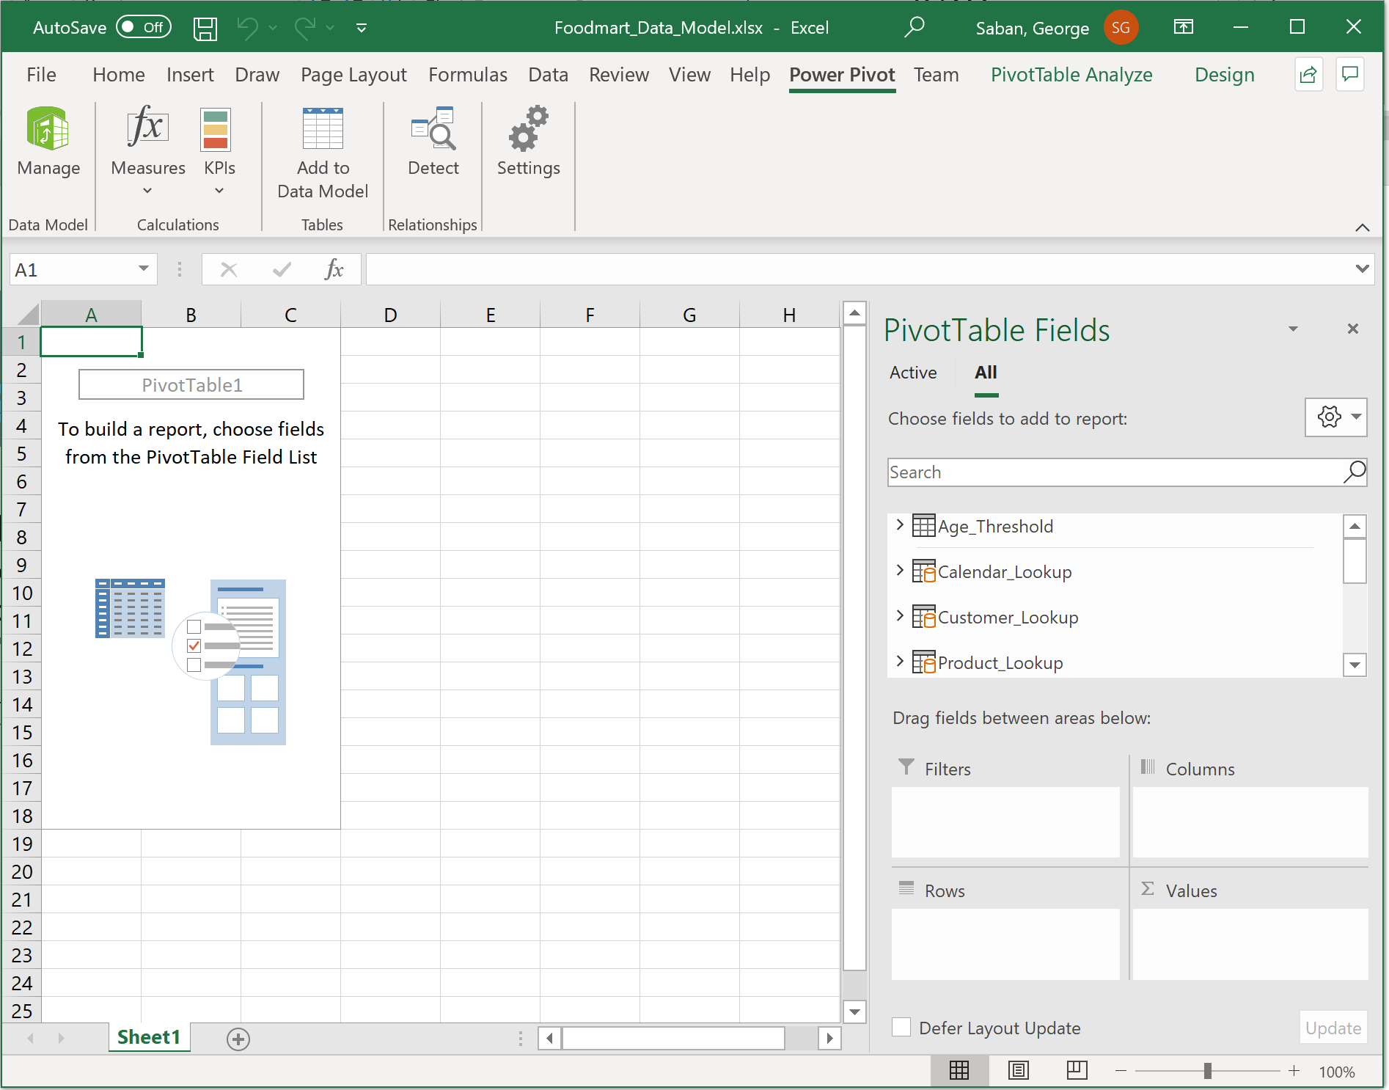

Go to the data model by pressing Manage, and select Customer_Lookup tab.

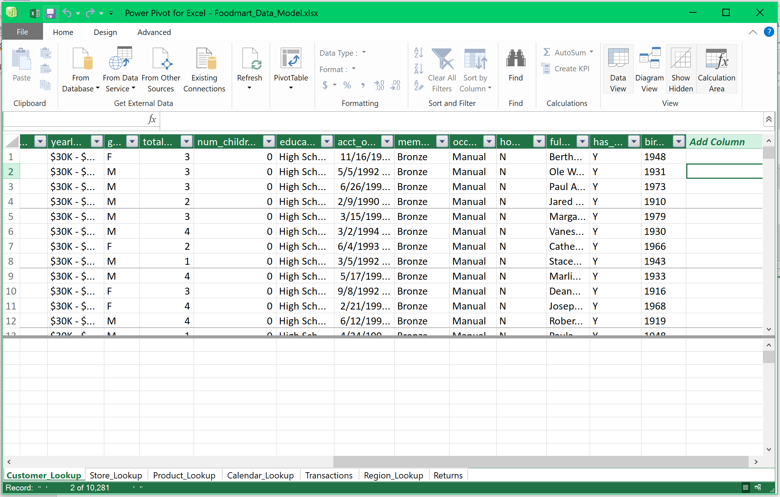



Scroll all the way to the right and place your cursor anywhere in the Add Column field.

Select the formula bar to get started.

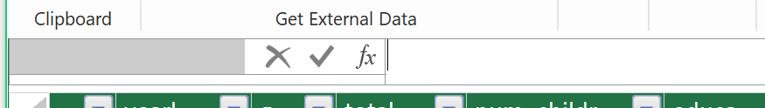



Write the DAX to produce the calculated column. Note that you may type the complete field name ‘Customer_Lookup’[birthdate], or you may click on the birthdate header title and it will automatically populate the column name for you.





Press Enter. You will see some hesitation where Power Excel is running the computations, and then a new calculated column will appear.

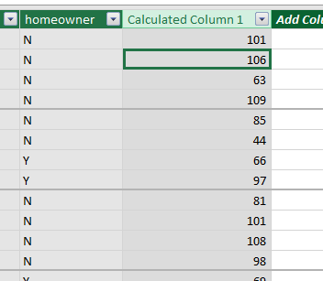



Rename the new column to “age” by double clicking on the header title.

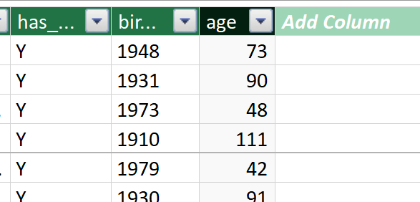



This is a valid use or a good example of the use of calculated columns.

Now, let us have another example. Go to the Product_Lookup tab. And select any cell under the Add Column field.

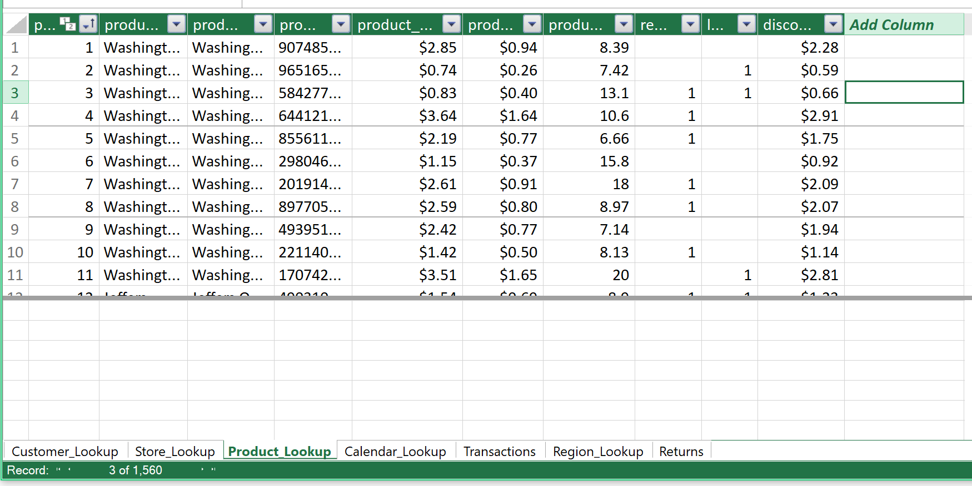







Click the formula bar and type the DAX formula below. Then press Enter.



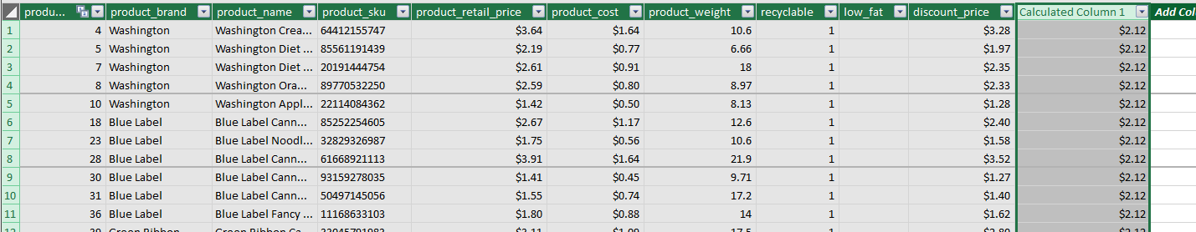



Observe that the new calculated column returns the same average value for every single row. This is an example of bad use of calculated columns. Single, exploratory, cumulative value like average or sum is better done using measures.

Remove this column because this is not really helping us, but instead, it is just occupying memory space, and it will also slow down future processes. Right-click the header title and select Delete columns > Yes to discard.

The final version of your Product_Lookup table should look like below.



There’s your quick primer on calculated columns. Make sure you save your work.

Reposition your screens so that the data model window is on top of the Excel window.

1. Take a snapshot using Window's Snipping Tool.
2. Make sure the system's date, Customer_Lookup tab, and the age field are included in the image.
3. Submit to Canvas in PNG format.

